# TCG Maker User Guide

Hi, and thank you for purchasing TCG Maker!

For feature suggestions and feedback please use the forum thread : <http://forum.unity3d.com/threads/237379-Trading-Card-Game-Maker>

If you need quick help or want some custom work done, my Skype is **melang1111**

Email: [admin@hommedemetier.be](mailto:admin@hommedemetier.be)

**Most of the art used in the demo is for demonstration purposes only, I don’t hold the rights to it.** Check the “Free art in TCG Maker” section to see which art assets you are free to use.

Contents

TCG Maker User Guide 1

1. Running the demo 2

2. Game Options 3

3. Creating and adding your own cards 4

Adjusting the game zones 4

4. Framework documentation 5

5. Setting Up Multiplayer 6

6. Free art in TCG Maker 7

# Running the demo

The current webplayer demo is located at <http://rien-ici.com/tcgmaker/>

Running the demo from Unity:

* Move the Plugins folder to the root of your Assets folder
* Add all the scenes from Assets/TCG to the build settings
* Set the resolution to 1024x600
* Add the “CardTemplate”, “Enemy” and “VictoryDefeat” tags to your project (tags can be added by choosing any GameObject in the scene, then clicking on its tag in the inspector and choosing “Add Tag ” )
* Run the MainMenu scene (you always have to run the game from this scene, otherwise it won’t work!)

The demo is almost exactly a Magic: the Gathering clone, because it's probably the most popular TCG out there. Each turn you can place a land (max 1), you tap (turn) lands to gain mana. Then you can use mana to play other cards such as creatures or spells - the mana cost of a card is in its upper left corner. Mana is reset to 0 at the beginning of each turn.

Creatures can attack the enemy player directly or other creatures. When they do, they deal their attack value (bottom left corner of a creature card) to the enemy. When a creature is being attacked by other creature, it retaliates, dealing its own attack value to the attacker. When a creature's life (bottom right corner) becomes 0 or less, the creature dies and goes to graveyard. Spells that has been cast also go to the graveyard.

Some creatures have activated abilities, you can access them by clicking with the right mouse button on a creature. They can have cost in mana - that means you will have to gain mana by tapping some lands before you can use the ability.

A creature that has attacked or used its activated ability becomes tapped (turned) - that means it cannot attack or use activated abilities again this turn.

# Game Options

These can really shape your game. They can be changed in MainMenu scene, Options gameObject.

*Game mechanics:*

**Starting Cards:** how many cards do the players start with. Default: 6

Note that by default, at the beginning of his/her turn the player draws a card, so the player who goes first will start with this +1 amount of cards.

**Starting Life:** how much life do the players start with. Default: 20

**Mana doesn’t reset:** check it if you want the mana to carry over to the next turn. Default: false

**Mana Auto-Increments Each Turn:** Hearthstone-style mana system, at the beginning of their turn, a player gains mana automatically. The amount of mana gained is 1 on the first turn and increases by 1 each turn. Default: false

**Mana Max Increment:** only matters if the previous option is set to ‘true’. Determines the maximum mana that can be gained at the beginning of a turn. After that, the mana gain will stop increasing each turn and will stay at that amount.

**First Turn Sickness:** used in both Magic: The Gathering and Hearthstone, this doesn’t allow a creature to attack or use its activated abilities on the first turn it is in game. Default: true

**Graveyard:** Magic: the Gathering- style graveyard, a game zone where dead creatures and cast spells go. If this option is disabled, they will just disappear. Default: true

**Can’t Attack Player That Has Heroes:** doesn’t allow a player to attack the opponent directly if the opponent has one or more ‘heroes’ in game. A hero card should have ‘hero=1’ in the database xml.

*Cosmetic options:*

Game Music: if set to true, the game will play the tracks from resources/TCG/audio/music/battle while in game. Default: false

Player Turn Popup: shows the “It’s your turn” popup at the beginning of each player’s turn. Default: true

TurnDegrees: degrees for when a card is turned (for mana or attacking). Default: -90

Card Frame Is Separate Image: somewhat a placeholder currently, because this mode is the only one that’s supported at the moment. If there is a demand, I will support the cards being a single image, but for readability and performance I recommend keeping card images and text separate. Default: true

Atk/Def Labels Size: changes the size of attack/defense creature labels’ text. Default: 1f

# Creating and adding your own cards

I’ve made a series of YouTube tutorials on how to create cards and a default deck with the Card Editor:

Note that **it’s strongly recommended not to delete any of the existing cards**, but to modify them instead. This ensures your card id’s always go from 0 to infinity, and will save you a lot of trouble when making decks.

Tutorial #1: preparing a sprite sheet in Photoshop

<http://youtu.be/rulfFoz79f0>

Tutorial #2: creating a simple card

<http://youtu.be/JJVdFKVm3tw>

Tutorial #3: creating spells, creatures with multiple abilities, etc

<http://youtu.be/Ds2BwT_YUuI>

Tutorial #4: adding the new cards to the offline deck

<http://youtu.be/3Khwgg8_iWs>

Tutorial #5: Adding the custom card stats

<http://youtu.be/ytaxzq-m8qE>

Custom stats can be accessed from the **card** class like this (replace “flavor text” with your custom stat name, including white spaces):

if (CustomStrings.ContainsKey("flavor text"))

string my_string_stat = CustomStrings["flavor text"];

if (CustomInts.ContainsKey("magic power"))

int my_int_stat = CustomInts["magic power"];

# Adjusting the game zones

Tutorial #6: Game zones – movement and rotation

<http://youtu.be/eThjwgbtTTY>

Tutorial #7: Game zones part 2 – invisible and face down, creating a new game zone

<http://youtu.be/0kB_bgvt34o>

If you want to add game mechanics for a new custom game zone, it will require some coding skills. Check out the AddCreature, RemoveCreature, AddLand, etc methods in Player.cs and Enemy.cs to see how the cards can be moved from one zone to another.

Alternatively, you could ask for a new mechanic to be added to the kit in the forum thread and I’ll see what I can do. ☺

# Framework documentation

If you want to add your own effects, targets or game mechanics, you’re going to need this. It’s probably best to request a feature in the forum thread though, because I’m constantly adding new effects and yours can be one of them.

The documentation on most of the classes is located in User Manual folder. I’ve finished documenting all game-related classes, will get to the rest of the classes soon. If something is not quite right there, contact me on skype please because I’m constantly making updates and I might have missed to update something in the docs.

An example:

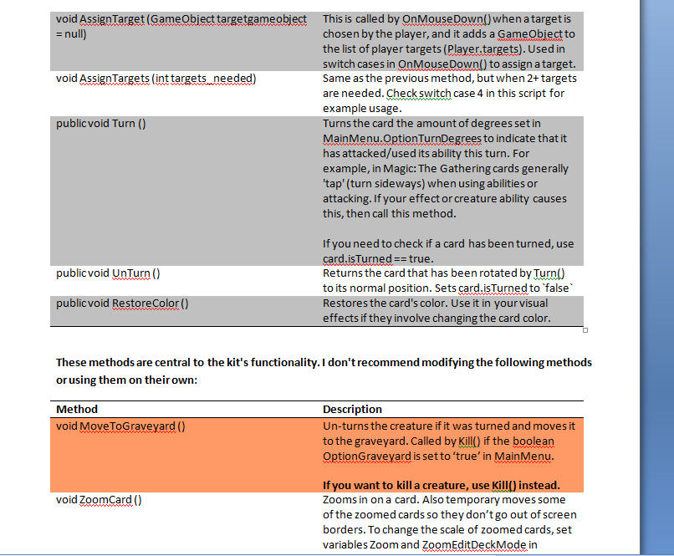

# Setting Up Multiplayer

Make sure that **PlayOffline** in MainMenu scene, gameObject Scripts is set to *false*, otherwise it won’t connect.

You will need a webserver with a mysql database that allows you to run php scripts on it that access the database. I think most paid webhosting servers that allow CMS like Drupal, Joomla, etc, will do.

1) Create these tables on your server:

player_collections: primary key int id, int user_id, int card_id

player_decks: primary key ID, int user_id, int card_id

silver: primary key id, int user_id, int silver

promo_cards: primary key ID, int card_id, int cost

users: primary key id, varchar(10) username, varchar(32) password, varchar(20)email

2) If you don't have a Photon Cloud account yet, register one - it's free and allows you up to 20 concurrent users.

Go to <https://www.exitgames.com/en/Account/SignUp>

3) In Unity go to window - photon unity networking - PUN wizard - settings - setup and enter your AppId that you can see in your Dashboard on exitgames site

4) Open one of the .php files in the PHP folder and edit these lines:

$host = 'localhost';

$user = 'secondhand_tcg';

$dbpassword = '111111';

$db = 'secondhand_tcg';

so they have your db login information. Then just copy and paste them from one .php file to another.

5) Upload the scripts from the PHP folder to your site

6) In MainMenu.cs change the website name in url, url_login, url_latest_cards etc from losange-vision.com to your site.

7) In Currency.cs do the same for mycurrencyURL

Try running the multiplayer mode now, but first check that the setting PlayOffline is set to 'false' in inspector in Scripts in MainMenuScene.

# Free art in TCG Maker

Some of the art that comes with TCG Maker is free to use for prototyping or even commercially! Most of it was donated specifically for TCG Maker (you can’t find it anywhere else on the web!), other art I have handpicked from various cc-by sites.

You can find it in the “Free art” folder, organized by artist’s name. You need to credit the artist in order to use their art for you game.

Note that the card frames, icons and spell particles were all made by me. You can use them as you please without attribution, though I would appreciate if you credit me, ex: “Melang for TCG Maker” ☺